Nandikaa Ganesh

Application Development Laboratory – Ex – 1(I)

Name: Nandikaa G

Roll No. 21z325

B.E. CSE G2 – III Year

Date: 20-12-2023

Course Code: 19Z612

**HTML - Introduction:**

HTML stands for HyperText Markup Language. It defines the meaning and structure of web content, Along with CSS and JavaScript, it is used to create webpages and websites

* **Hypertext** means that it links and cross-references to other webpages (to one another), within a single website or between websites. Basically, it can hyperlink to other pages (created by other people or yourself).
* **Markup** means it can structure the content for display in Web Browser. It uses tags and elements to structure and format the text and other content for presenting it on the Web.

**HTML – Structure and Elements:**

**Elements:**

* HTML – defines structure
* CSS – Style
* JavaScript – Behavior

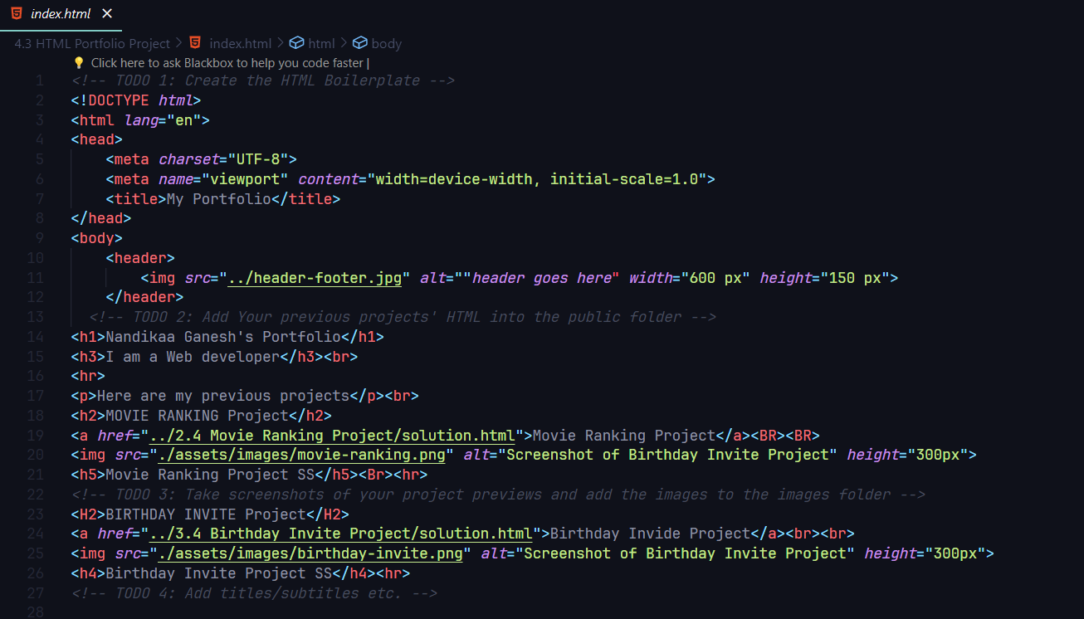

A HTML document consists of **elements.** Elements enclose or wrap the content to make it appear or act in a certain way. Element is the basic unit of a HTML document. A HTML document is saved with .html extension.

A HTML element comprises of the following:

1. **Opening tag**
2. **Closing tag**
3. **Content**
4. **Attribute**

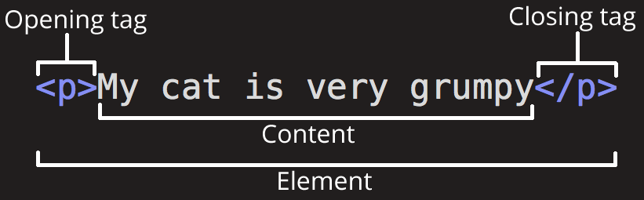

It is to be noted that the element need not have a closing tag or attribute or content all the time. But certain elements do need all the four.

**Opening tag:**

The name of the element is wrapped in opening and closing angular brackets. Indicates the starting of the element

**Closing tag:**

The name of the element is wrapped in opening and closing angular brackets, with a ‘/’ in the before the element. Indicates the end of the element.

**Content:**

The content is the text on which the element takes effect.

**Attribute:**

Attributes are extra information to the element. It will determine the behavior of the content based on the element and tag.

Basic HTML tags - Document Tags, Grouping Tags, Head Tags, Body Tags, Text-level Flow Tags, O**rdered Lists, Unordered Lists, Definition Lists, Table Tags, Table borders**

**Types of Tags:**

1. Non-Void Tags – which needs both opening and closing tags. **E.g.: heading tags, span tags**
2. Void or Self-Closing tags – which has only the opening tag **E.g.: break, horizontal line**

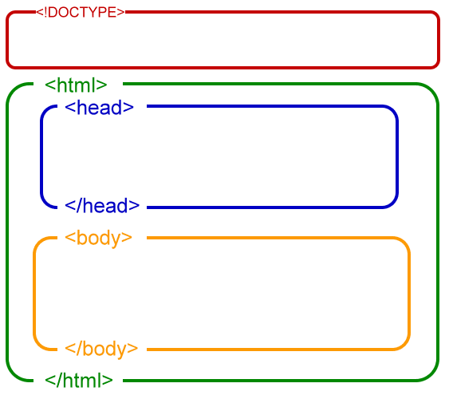

**Document Tags:**

A HTML Boilerplate looks like this:

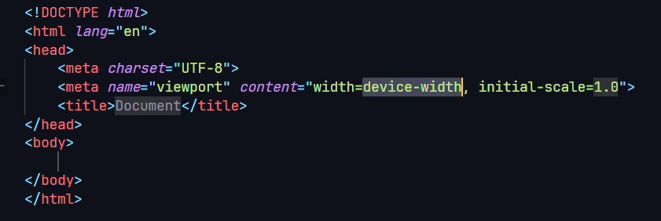

Where the Document tags are

<!DOCTYPE *html*>

<html *lang*="en">

<!DOCTYPE *html*>

Is the Document Declaration tag. It denotes the version of HTML used.

<html *lang*="en">

Denotes the root of HTML document and language attribute is set to English language

**Head Tags**

Contains the meta-information about the HTML document

    <meta *charset*="UTF-8">

    <meta *name*="viewport" *content*="width=device-width, initial-scale=1.0">

    <title>Document</title>

Contains the character set encoding,

1. **<meta charset="UTF-8">**:
   * This meta tag defines the character set used in the HTML document.
   * **UTF-8** is a character encoding that supports a wide range of characters, making it suitable for encoding text in various languages.
2. **<meta name="viewport" content="width=device-width, initial-scale=1.0">**:
   * This meta tag is related to the viewport settings of the web page.
   * **width=device-width** sets the width of the viewport to the width of the device screen.
   * **initial-scale=1.0** sets the initial zoom level when the page is first loaded. A value of **1.0** means no zoom.
3. **<title>Document</title>**:
   * The **<title>** element is used to define the title of the HTML document, which is displayed on the browser's title bar or tab.
   * In this case, the title is set to "Document." You can replace "Document" with the desired title for your web page.

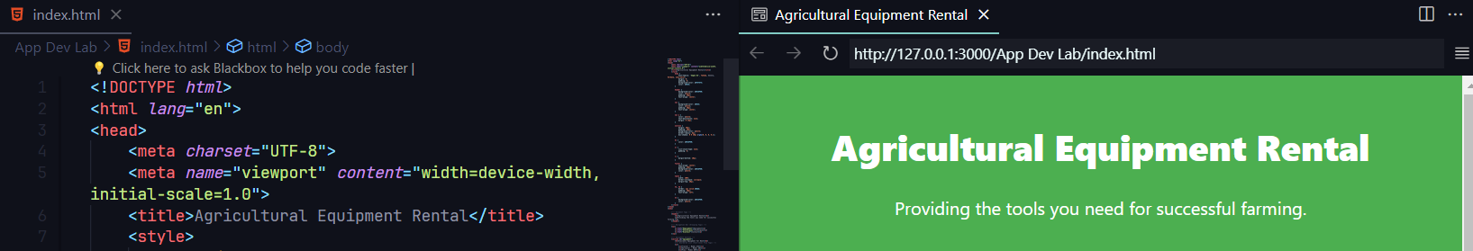

Since the title is given as “Agricultural Equipment Rental” the same is displayed on the browser tab.

**Body tags:**

Following the HTML head tags are the body tags

Body tag contains all the content that the web users can see when they visit the page. May it be text, images, videos, games, playable audio tracks or whatever else, the body tag will enclose them.

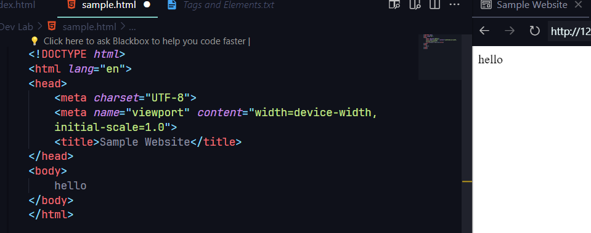

Any text enclosed within the body tag will be by default displayed in the web page

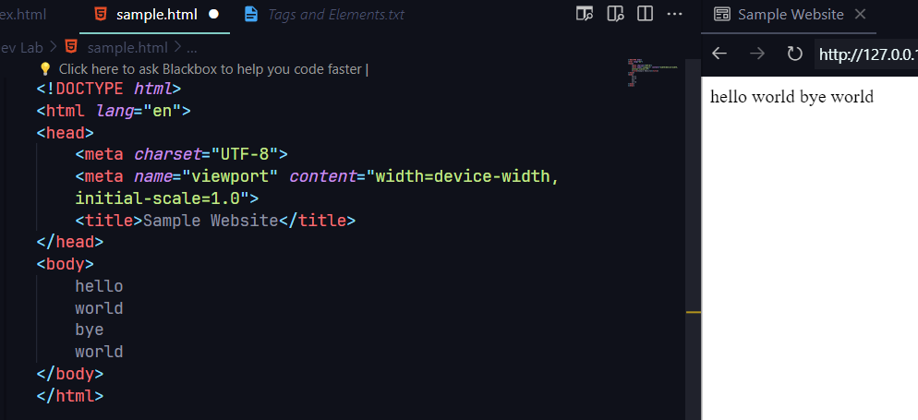

If any formatting done without the use of tags, the text will be displayed inline without any formatting. For formatting to be reflected in the web page we will need the use of tags

**Heading tags:**

Heading elements allow you to specify that certain parts of your content are headings — or subheadings. In the same way that a book has the main title, chapter titles, and subtitles, an HTML document can too. HTML contains 6 heading levels, <h1> to <h6> although we will commonly only use 3 to 4 at most:

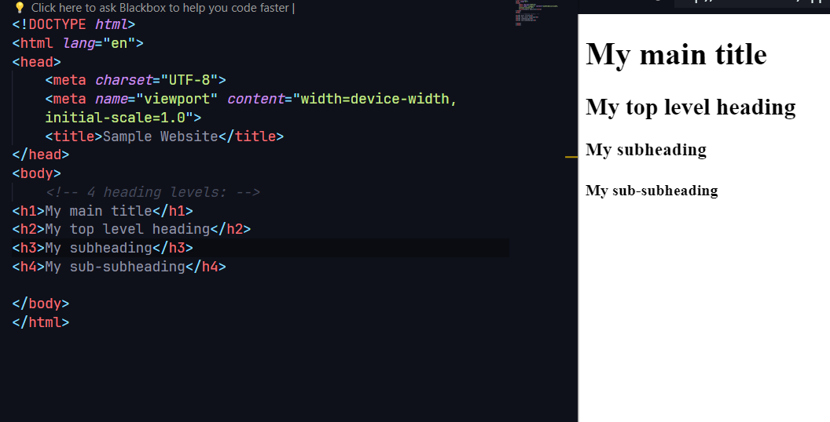

**Paragraph element:**

<p> elements are for containing paragraphs of text; we will use these frequently when marking up regular text content. Even though the content inside the paragraph element is split into paragraphs they are displayed as a single paragraph in web page.

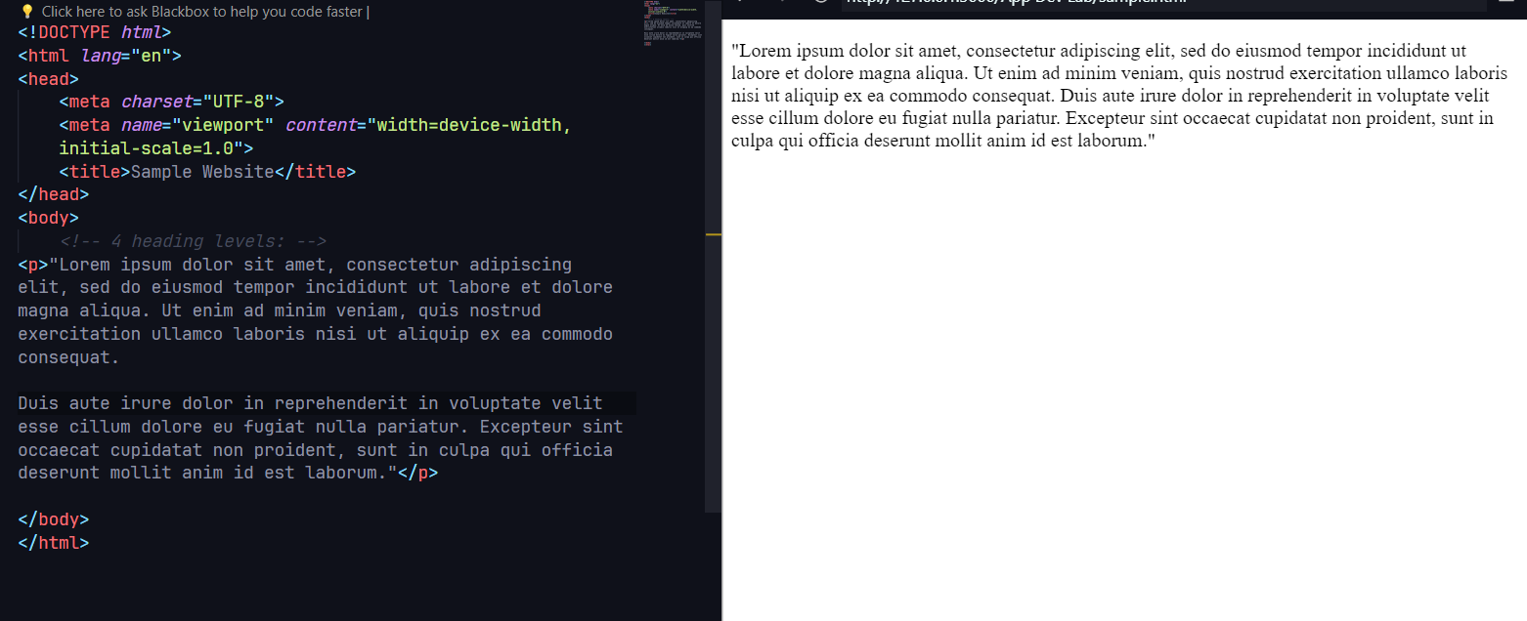

**Grouping Elements:**

Grouping tags in HTML are used to structure and organize content within an HTML document. They do not affect the appearance of the content but provide a way to group and nest elements. Here are some common grouping tags in HTML:

1. **<div> (Division):**
   * **<div>** is a generic container that does not carry any semantic meaning.
   * It is often used to group and style elements together.

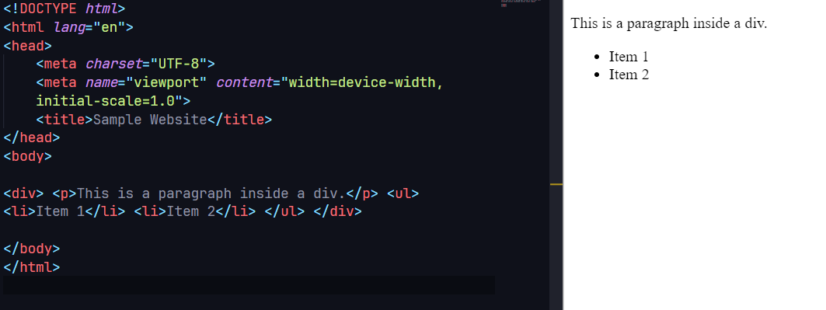

1. **<span>:**
   * **<span>** is an inline container used for styling purposes or targeting specific portions of text.

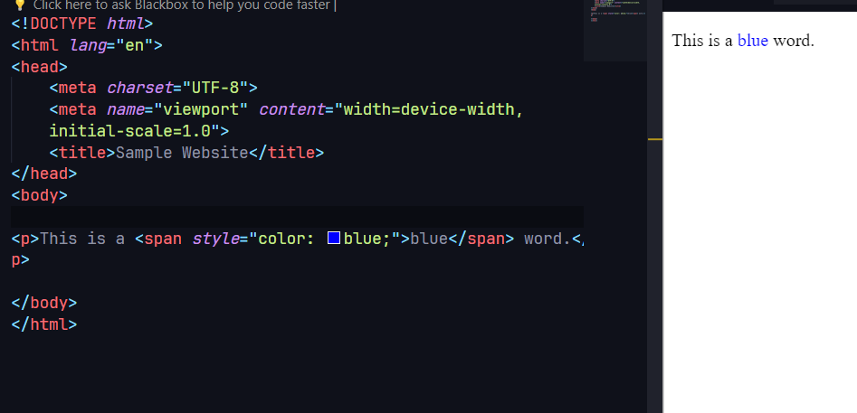

1. **<section>:**
   * **<section>** represents a thematic grouping of content and typically includes a heading.

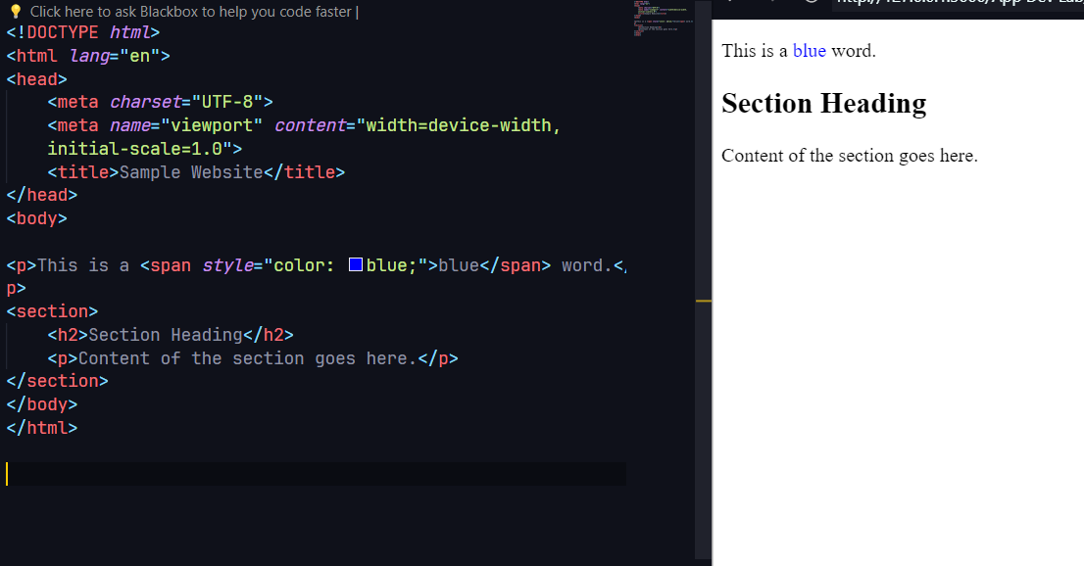

1. **<article>:**
   * **<article>** represents a self-contained piece of content that can be distributed and reused independently.

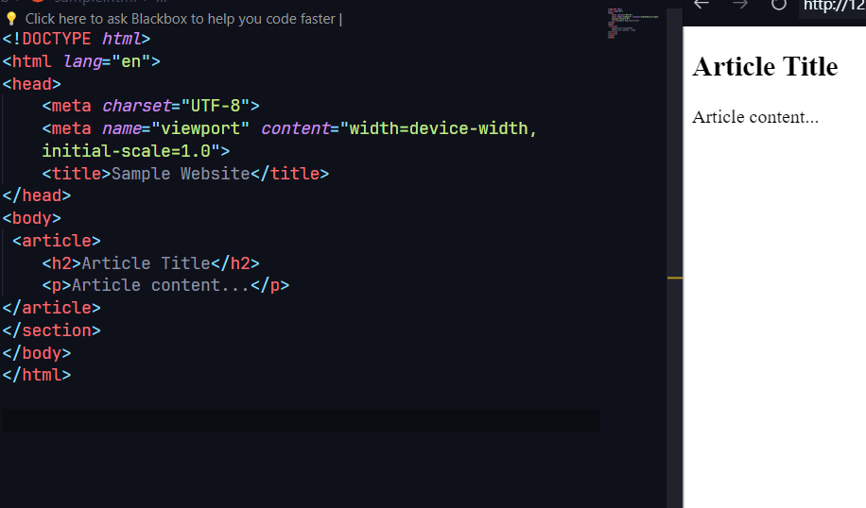

1. **<header>:**
   * **<header>** typically contains introductory content or a group of introductory elements.

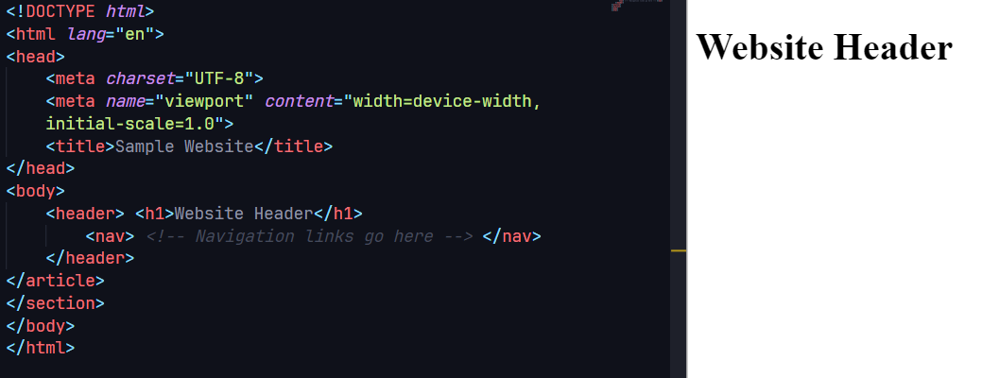

1. **<footer>:**
   * **<footer>** typically contains information about the author, copyright, or related links.

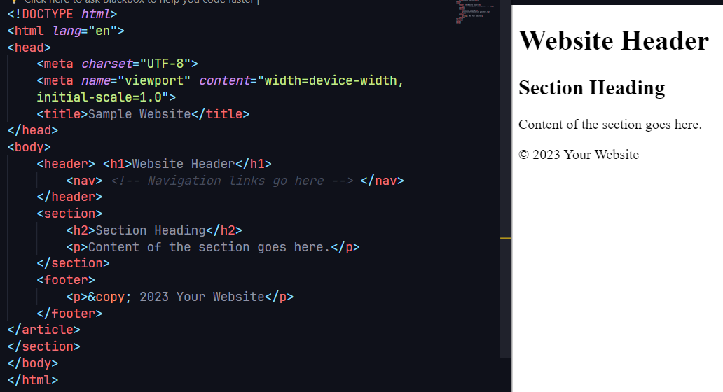

1. **<nav>:**
   * **<nav>** represents a navigation menu or links.

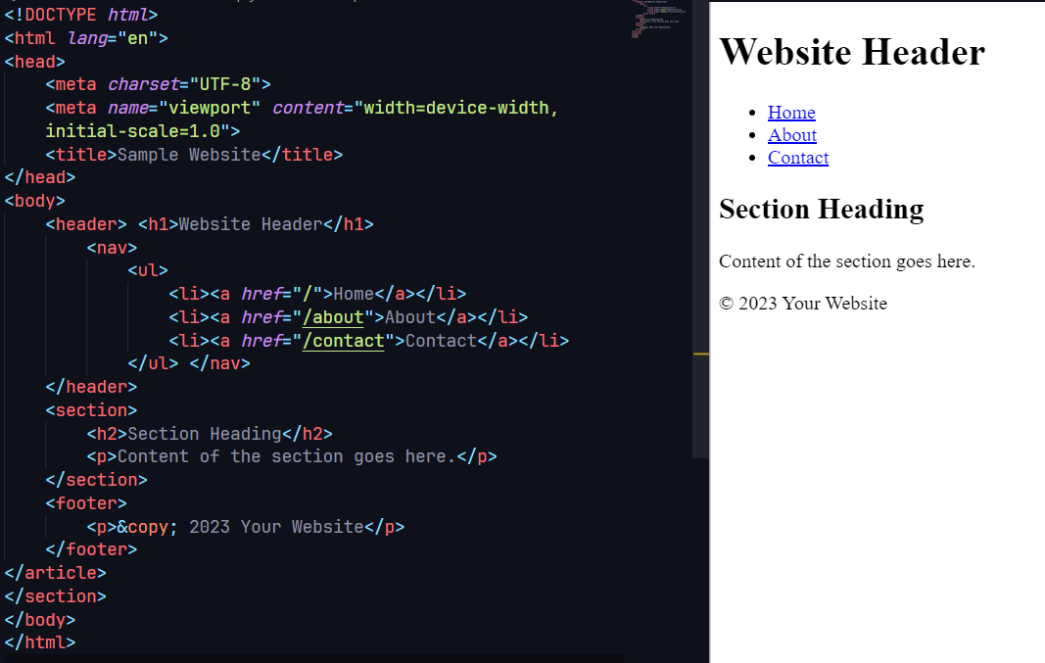

These grouping tags help organize and structure content in a meaningful way, making the HTML document more readable and maintainable. They play a crucial role in creating a well-structured and semantically meaningful web page.

**Text-level flow tags:**

Text-level flow tags in HTML are used to structure and format text within the content of a webpage. These tags affect the presentation or styling of individual pieces of text. Here are some common text-level flow tags:

1. **<a> (Anchor):**
   * Used for creating hyperlinks. It can link to other web pages, resources, or locations within the same page.

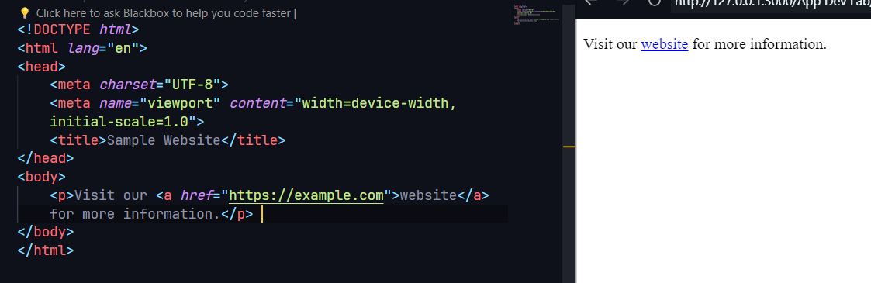

1. **<strong>:**
   * Represents strong importance or importance of a strong nature, often displayed as bold text.

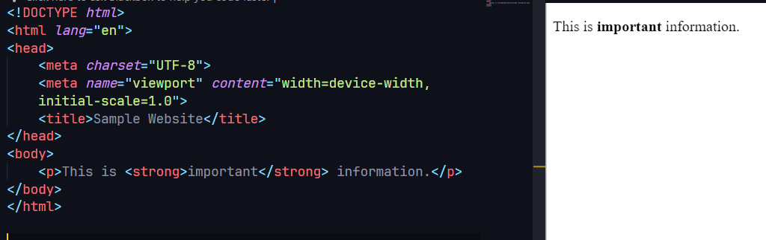

1. **<em> (Emphasis):**
   * Represents emphasized text, typically displayed as italicized.

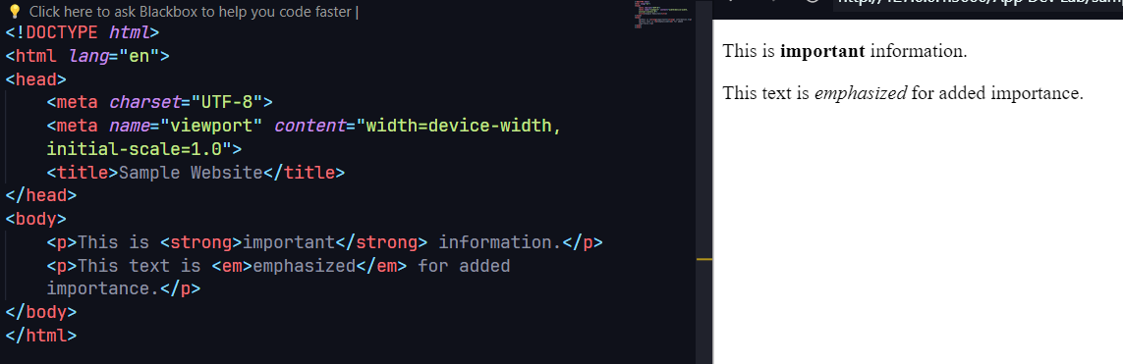

1. **<abbr> (Abbreviation):**
   * Represents an abbreviation or acronym, and the title attribute can provide the full version.

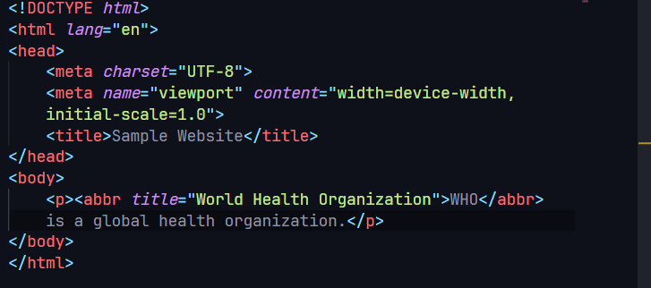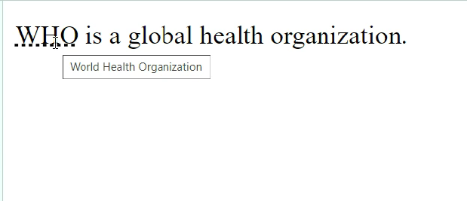

1. **<cite> (Citation):**
   * Represents the title of a creative work, such as a book or a movie. It is often used within the **<blockquote>** element.

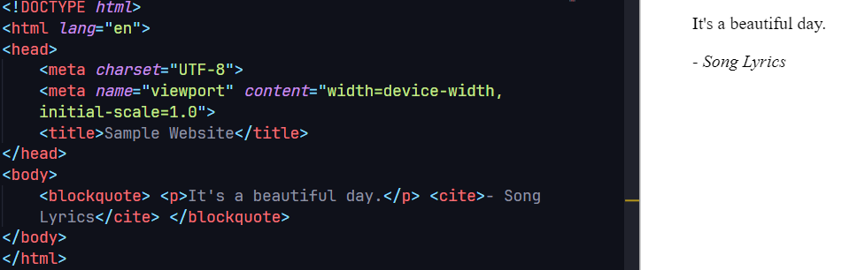

1. **<code>:**
   * Represents a single line of code or code fragments within text.

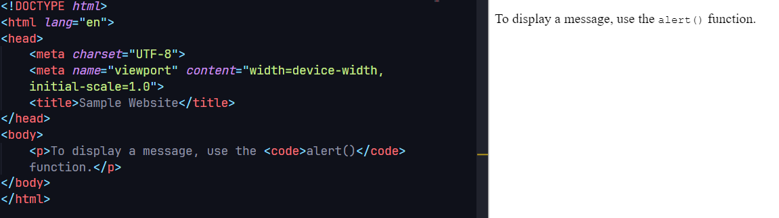

1. **<br> (Line Break):**
   * Represents a line break within text, forcing the content that follows it to appear on a new line.

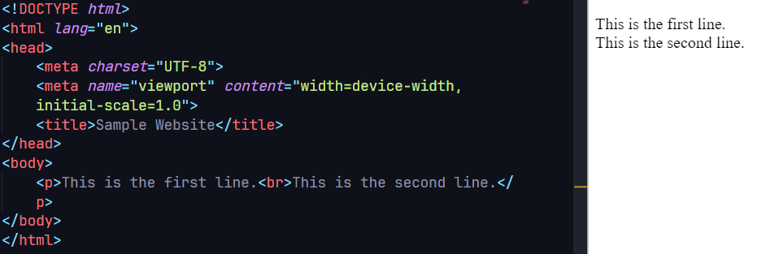

1. **<mark>:**
   * Represents text highlighted or marked for reference or emphasis.
2. **<small>:**
   * Reduces the text size, typically used for small print or fine print.

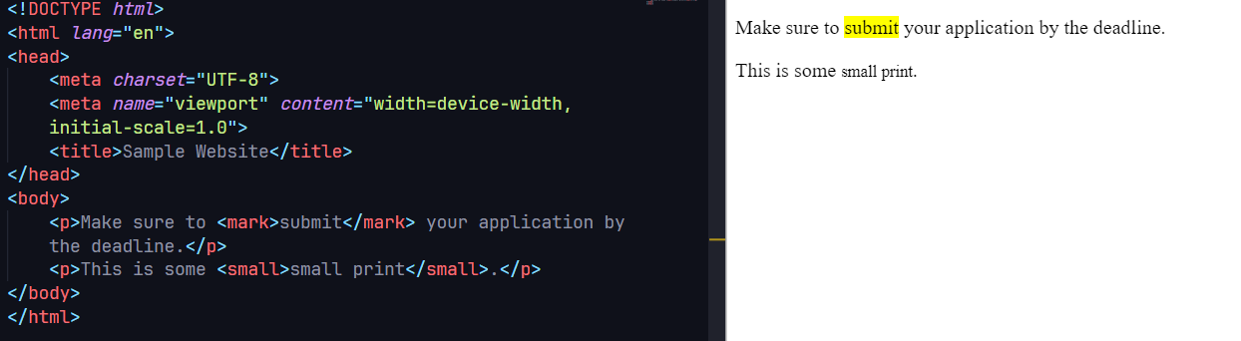

**Ordered Lists (<ol>) and List Item (<li>):**

The **<ol>** element is used to create an ordered list, and each item within the list is represented by the **<li>** element.

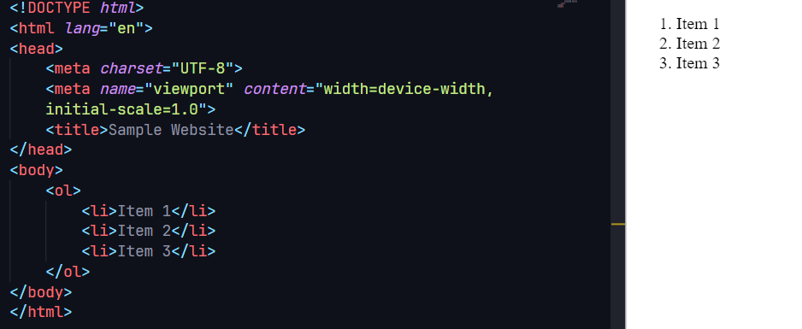

**Unordered Lists (<ul>) and List Item (<li>):**

The **<ul>** element is used to create an unordered list, and each item within the list is represented by the **<li>** element.

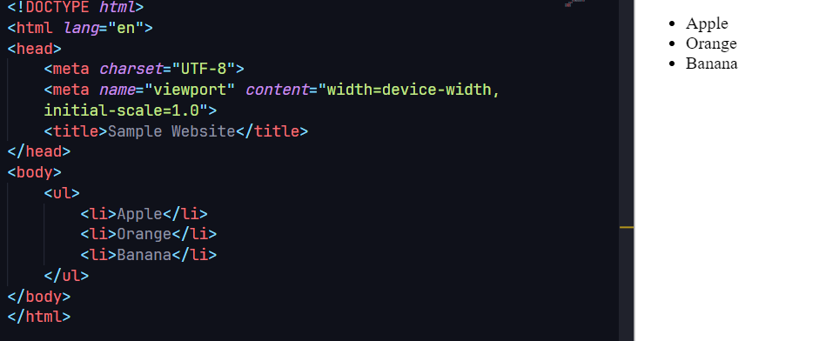

**Definition Lists (<dl>), Definition Term (<dt>), and Definition Description (<dd>):**

The **<dl>** element is used to create a definition list, where each term is represented by the **<dt>** element, and its definition is represented by the **<dd>** element.

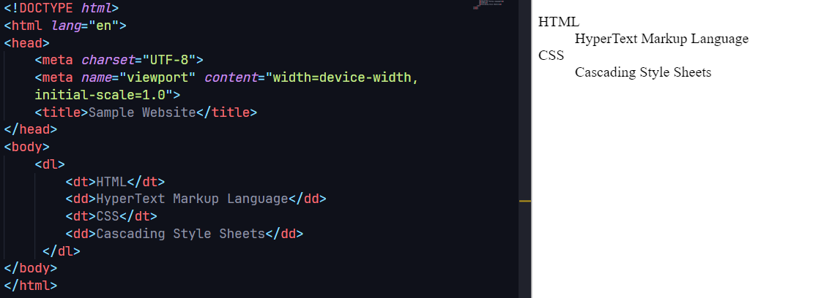

**Table Tags (<table>), Table Row (<tr>), Table Header (<th>), and Table Data (<td>):**

The **<table>** element is used to create a table, and within it, you have rows represented by **<tr>**, header cells represented by **<th>**, and data cells represented by **<td>**.

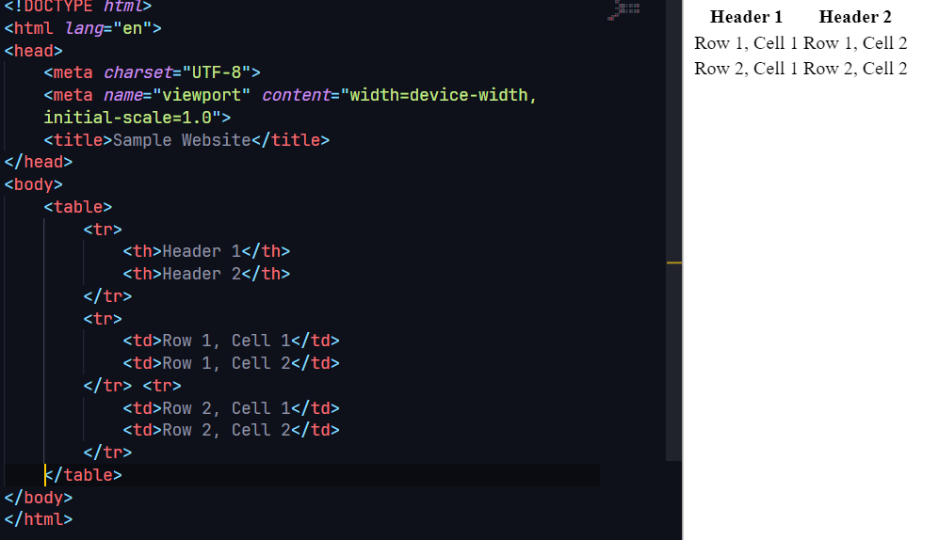

**Table Borders with CSS:**

You can use CSS to add borders to table cells for better styling.

Include the style block in the **<head>** section of your HTML document. It sets the **border-collapse** property to collapse borders into a single border, and **th** and **td** elements have a border, text alignment, and padding applied.

This will render a table with borders around cells. Adjust the styles as needed for your design.

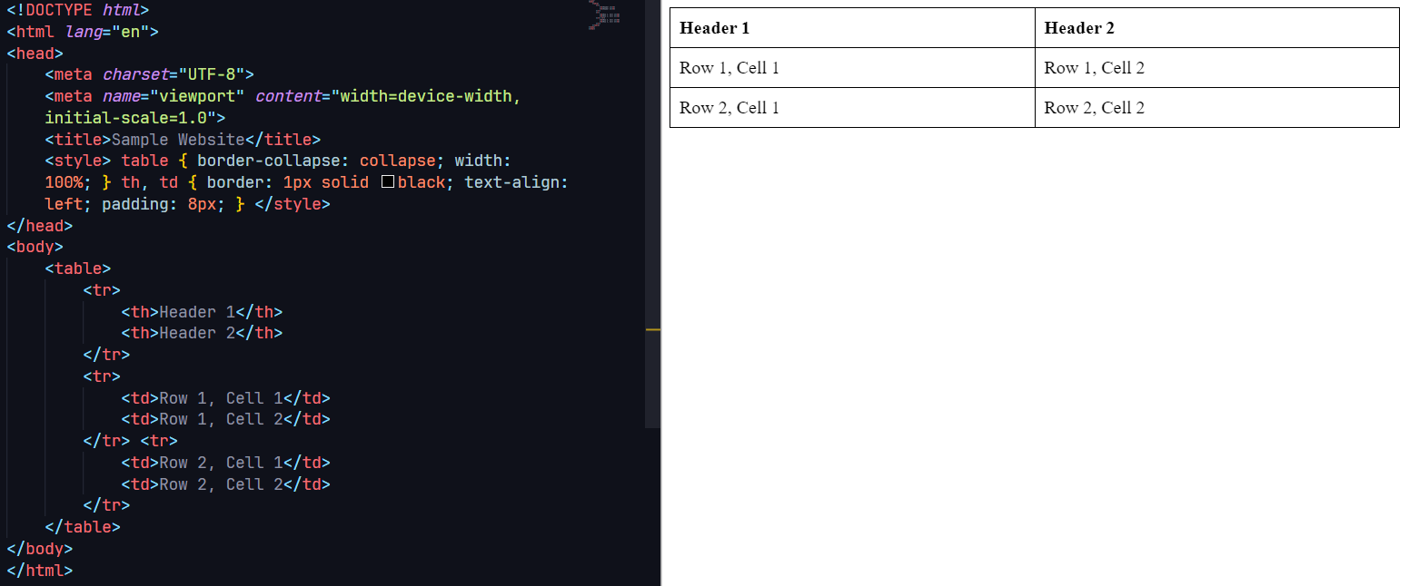

**Result:**

Thus, all the basic HTML tags and their functionalities with output has been seen. We will use these tags in developing the website – Agriculture Equipment Rental app.